Paul Polsinelli

IFT 220 – 90917a

8/31/20

Lab 3

1. Open VMware Workstation (be sure to update to latest version and for Windows 10 to be completely updated or this install will not work). Click Create a New Virtual Machine.

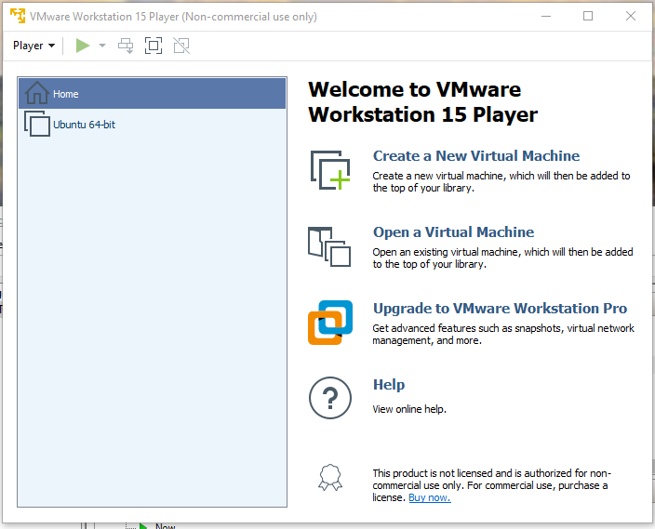

1. Choose where you will install Windows Server 2019 from. Click Next.

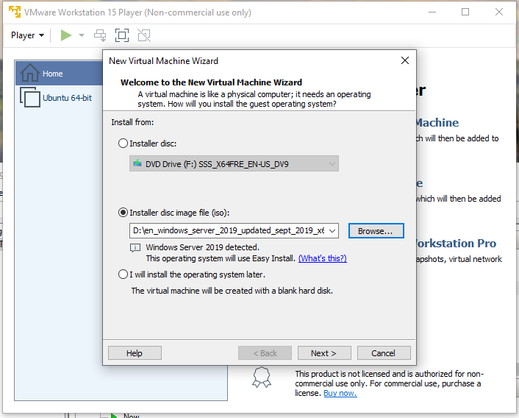

1. Enter the product key, version, name, and password if desired. Click Next.

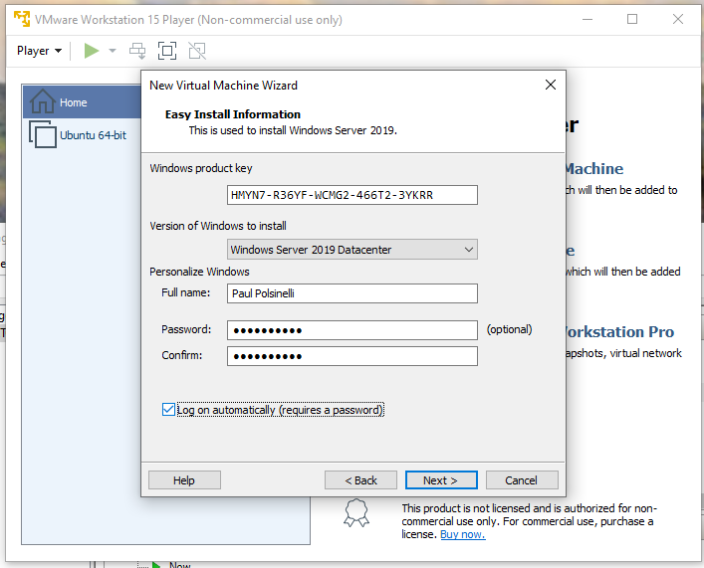

1. Name your machine and designate its location. Click Next.

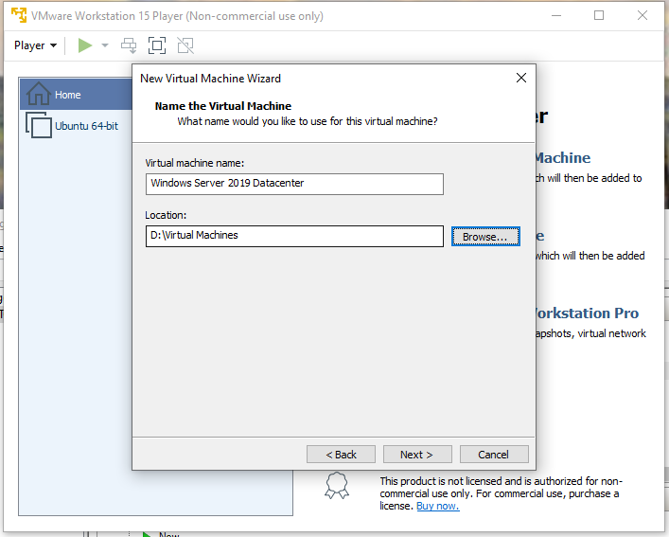

1. Specify your disk capacity. The software automatically recommended 60 GB for Windows Server 2019 so I left it. Click Next.

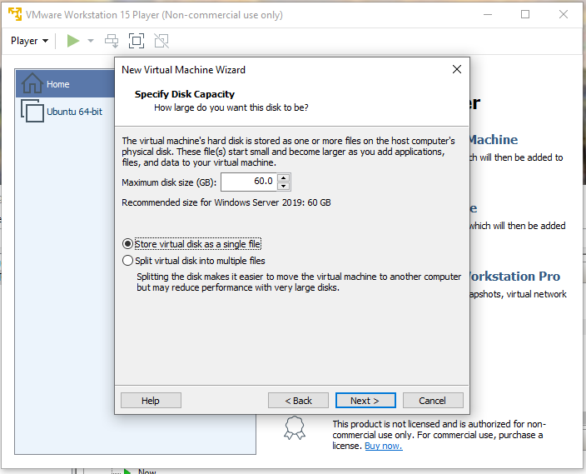

1. Review your settings and click Finish.

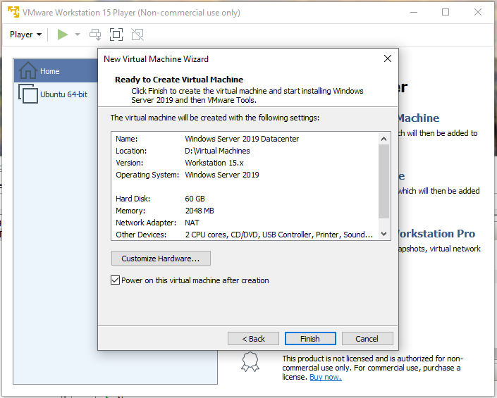

1. Install will begin automatically.

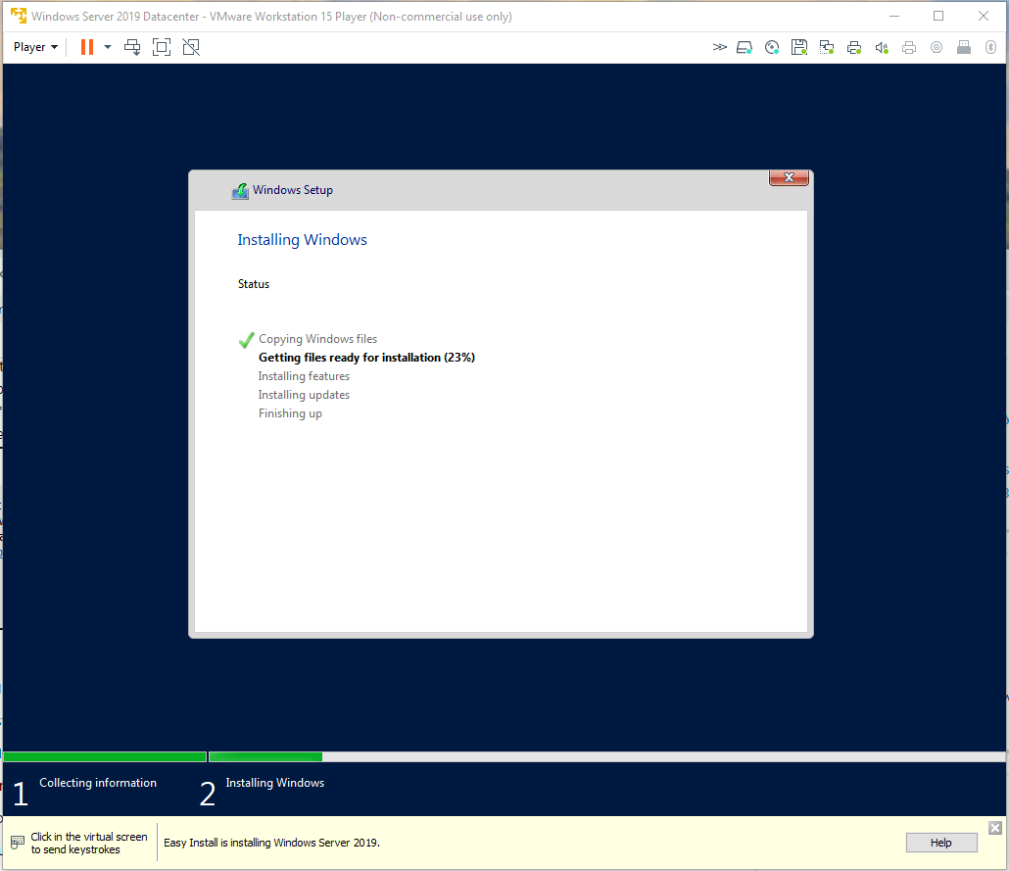

1. Windows will restart.

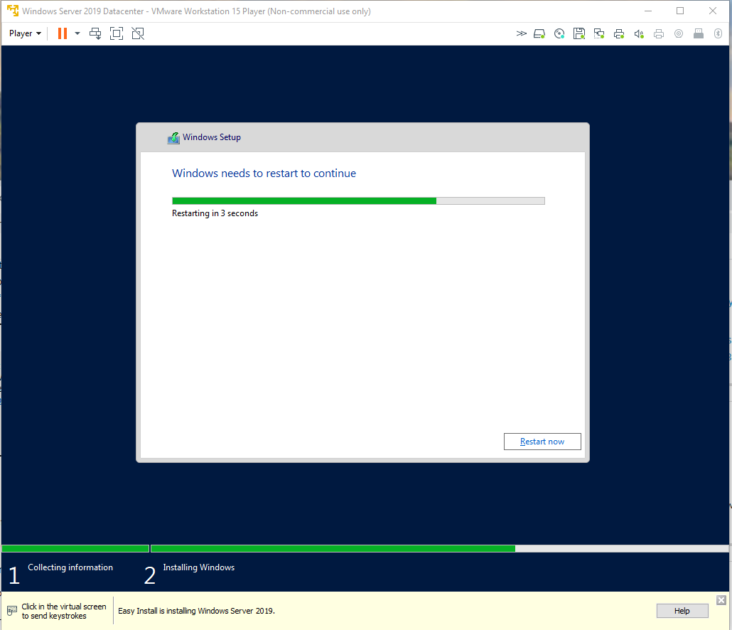

1. Server is installed.

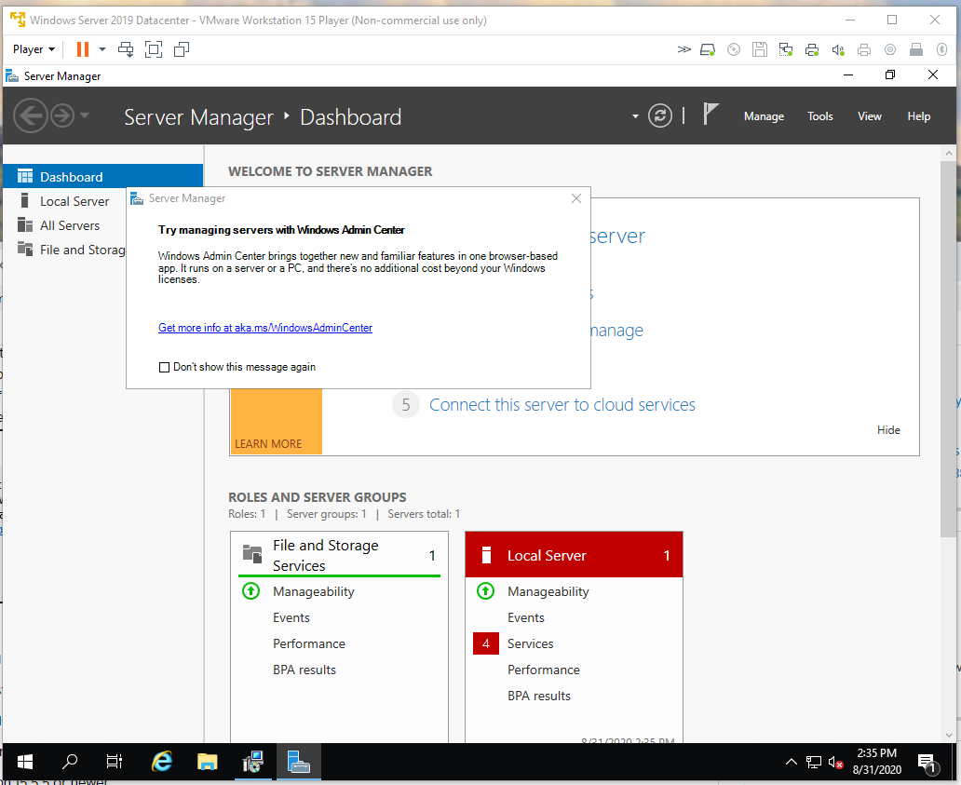

1. Open up the website <https://www.microsoft.com/en-us/download/details.aspx?id=45520> and click Download.

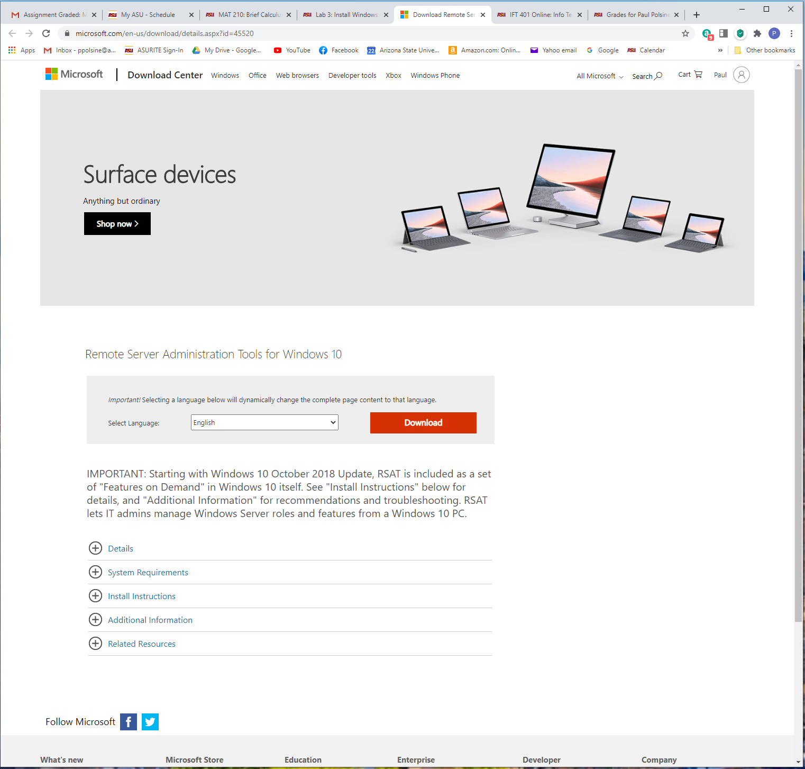

1. After downloading from <https://www.microsoft.com/en-us/download/details.aspx?id=45520>, open the installer for the Remote Server Administrator Tools. Click Open.

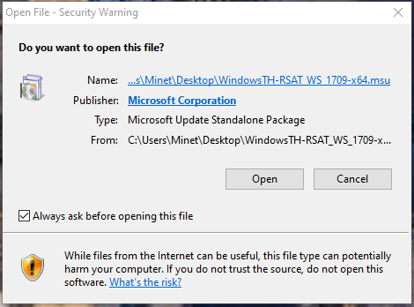

1. Click Yes.

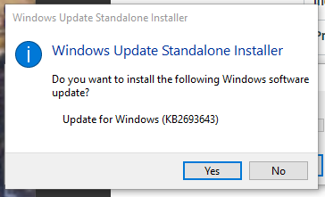

1. Click I Accept.

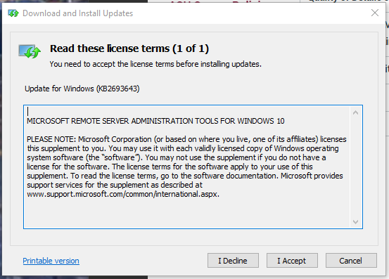

1. Installation complete. Click Close.

